Grade 7 Accelerated · Unit 3 · Thread A · Day 1  Exponent Laws with Variable Bases  Independent Set 3.T1 ANSWER KEY | Name  Date  Period

Six questions, on your own, in silence. Show the step that does the work.
1. Write as one power. 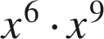
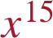

2. Write as a single monomial. 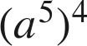

Power of a power: multiply.

3. Write as a single monomial. 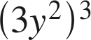
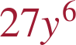
The 3 is raised too.

4. Write as a single monomial. 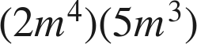

Coefficients multiply; exponents add.

5. Write as a single monomial. 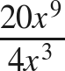
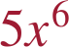
Coefficients divide; exponents subtract.

6. Find the value of . 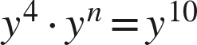
n = 6
4 + n = 10.

